Title: Efficiency Optimization in Wireless Inductive Power Transfer for Electric Vehicle Charging

Abstract:
Inductive power transfer (IPT) technology can have both the transmitter and receiver insulated and contactless, and thus shows versatility in wireless electric vehicle (EV) charging under hostile environments where physical connection is inconvenient or impossible. However, it is challenging for an IPT converter to maintaining a high efficiency while complying with the charging profile of the EV battery. This tutorial starts with this challenging issue, followed by an efficiency optimization principle and several methods for good efficiency performance in wireless EV charging. These methods will share ideas of load-independent-transfer characteristics, linear transfer functions, active rectification, active compensation, and so on. A thorough introduction to these methods will be provided with an emphasis on the application of each method for high-efficiency wireless EV charging. This tutorial will touch on the topic of development for efficiency optimization in bidirectional wireless EV charging for future grid-to-vehicle and vehicle-to-grid operations. A summary and conclusions will be drawn towards the end of the tutorial.

Bio:

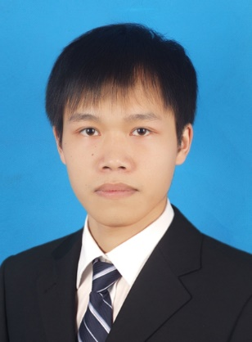
Zhicong Huang received the BSc degree in Electrical Engineering and Automation and the MPhil degree in Mechanical and Electronic Engineering from Huazhong University of Science and Technology, China, in 2010and 2013, respectively. He received the Ph.D. degree in Power Electronics from The Hong Kong Polytechnic University, Hong Kong, in 2018. He was the recipient of the UM Macao Talent Program and worked as a Postdoc Fellow in the State Key Laboratory of Analog and Mixed-Signal VLSI at University of Macau, Macao, in 2019. Since 2020, he has been an Assistant Professor in the Shien-Ming Wu School of Intelligent Engineering at South China University of Technology.
Dr. Huang has conducted extensive research on facilitating the interface of wireless power transfer more robust, user-friendly, and cost-effective for charging and powering electrical appliances like electric vehicles, automated guided vehicles, autonomous underwater vehicles, biomedical implants, etc. He has received research grants from National Natural Science Foundation of China, Guangzhou Municipal Science and Technology Bureau, and Science and Technology Development Fund – Macao, as a principal/co-principal investigator. He has authored/co-authored more than 20 technical papers. His research on wireless power transfer for the exploitation of distributed photovoltaic energy received the Best Track Paper Award in 2019 IEEE PES Asia-Pacific Power and Energy Engineering Conference.
Dr. Huang is an active IEEE member. He served as a Session Chair in 2019 IEEE PES Asia-Pacific Power and Energy Engineering Conference and 2020 Annual Conference of the IEEE Industrial Electronics Society. He has been a peer reviewer for various IEEE journals, including TPE, TIE, JESTPE, TVT, TCAS-I, TCAS-II, TTE, etc. He is also an IEEE Entrepreneurship regional (R10) ambassador. His current research interests include wireless power transfer, power electronics penetrated power system, charging robots, etc.

